# Detailed Design Document

## Use case one：Start Game

1. Design of input interface, output and database design:

* input interface：

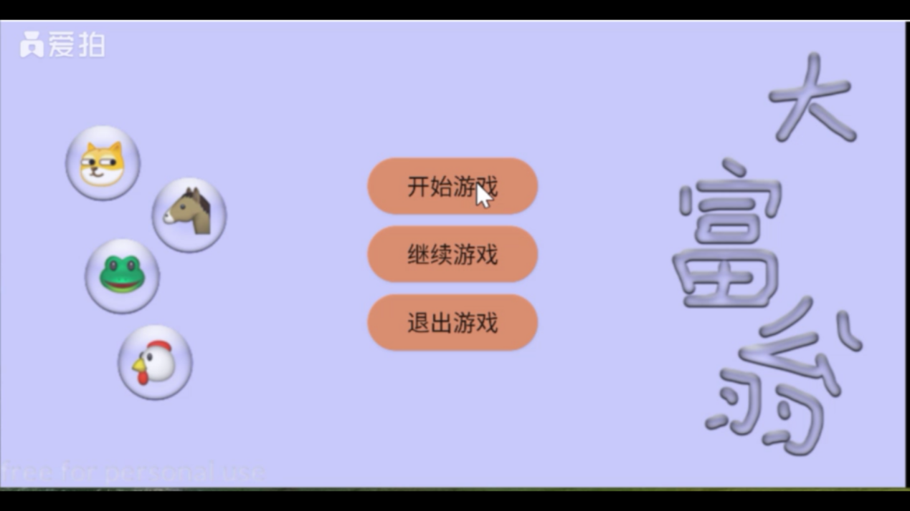

Entry：Start game button coordinates or continue game button coordinates or exit game button coordinates。

* output interface：

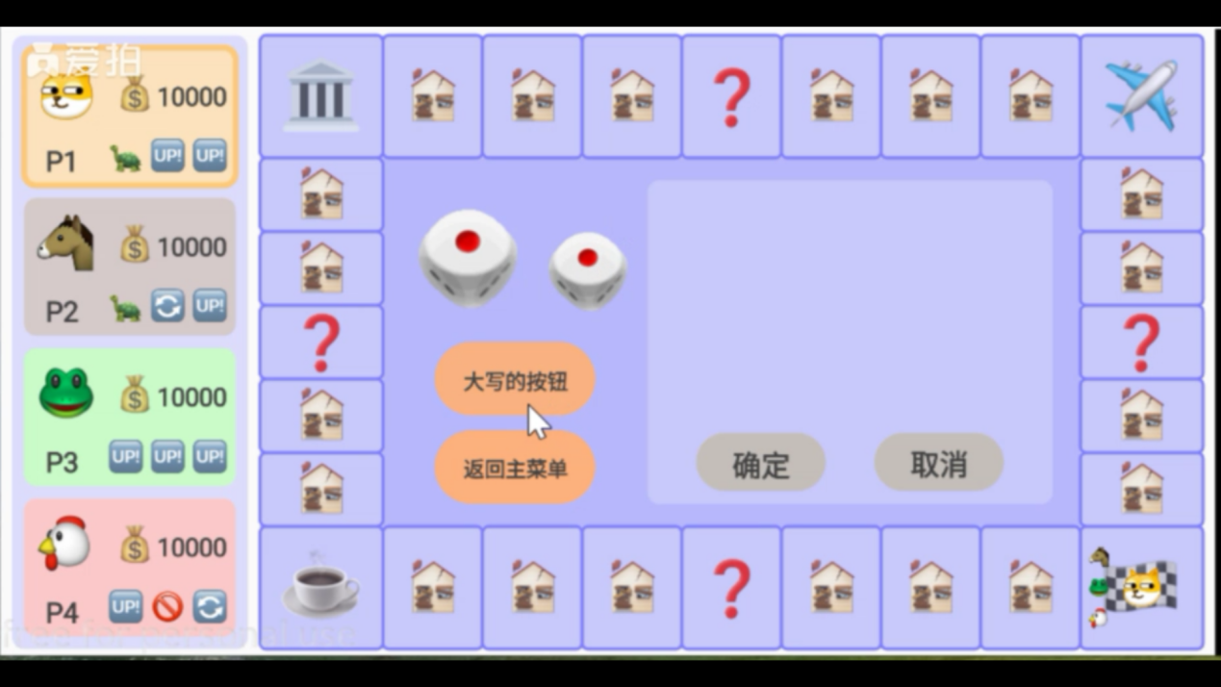

* database design:

no

1. Participation class:

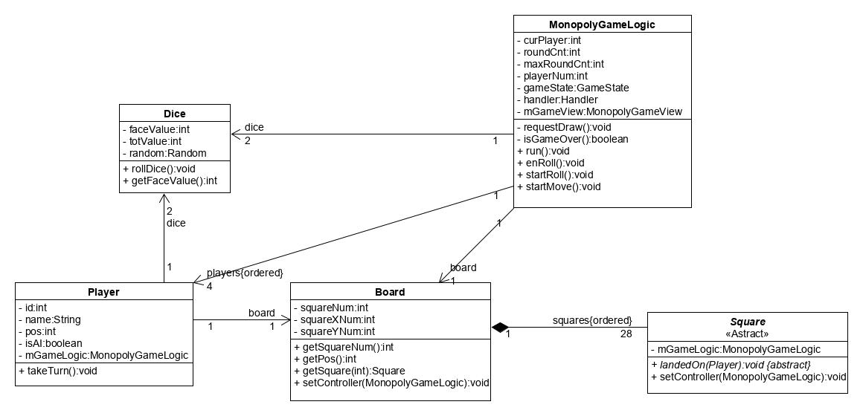

MonopolyGameLogic: It is used to initialize various kinds, create an orderly player list, and inform players to start the game round.

Player：Accept the notification of the system start turn and start the game.

1. Activity diagram:

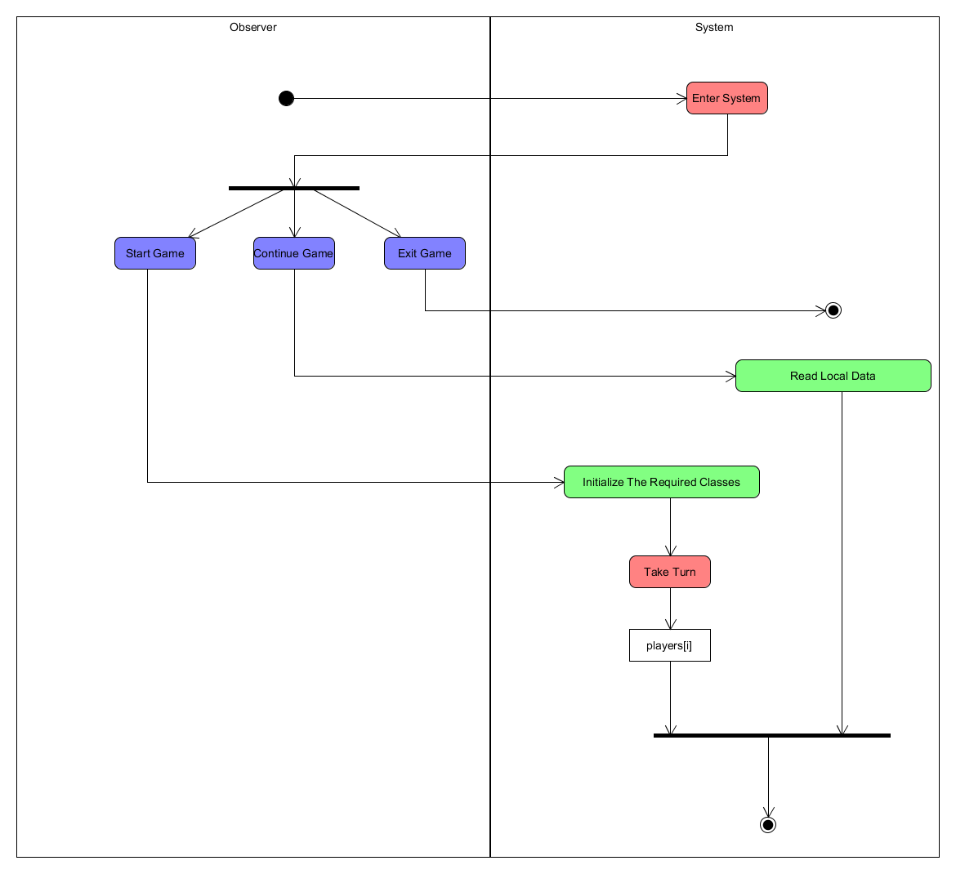

1. State transition diagram of key objects:

Players[i]：

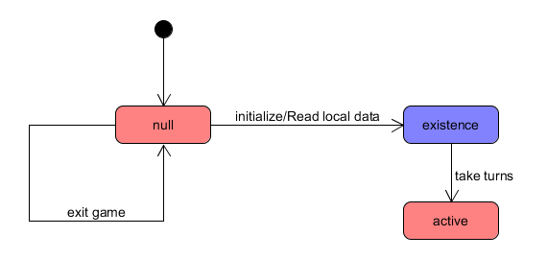

## Use case two：Use Propcards

1. Design of input interface, output and database design:

* input interface：

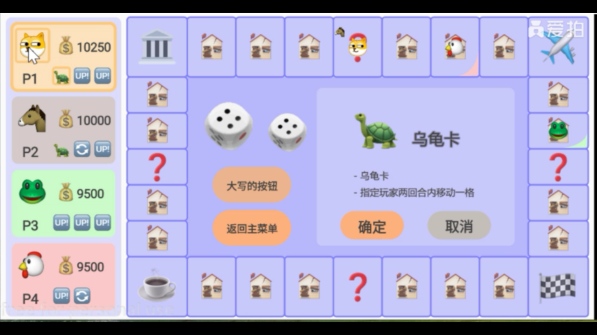

Entry: types of propcards and its used objects

* output interface：

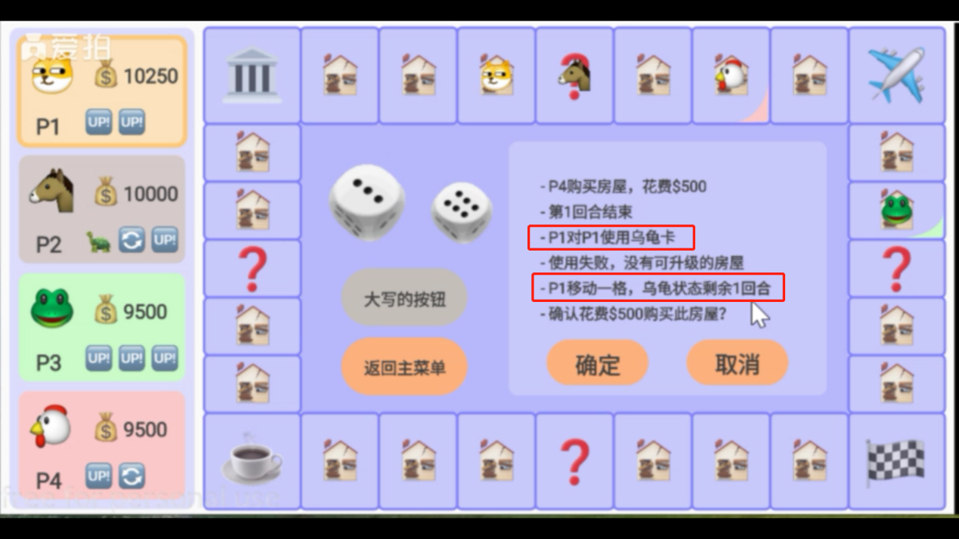

* database design:

no

1. Participation class:

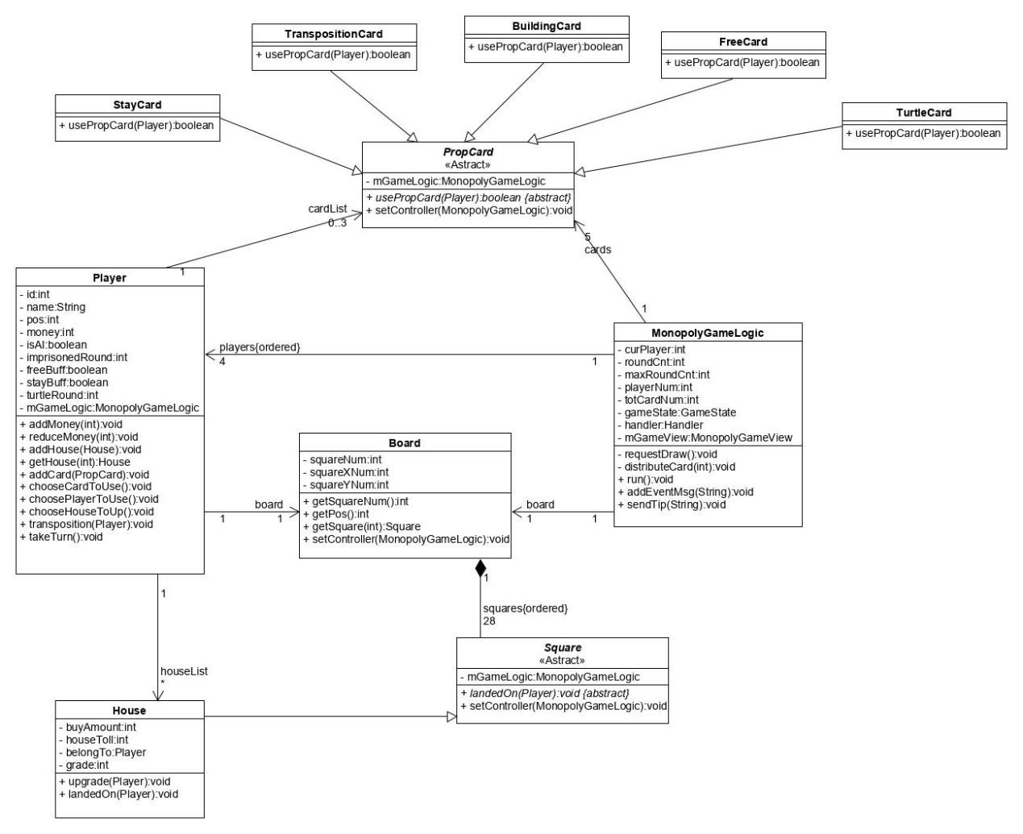

PropCards: An abstract class, used to derive all kinds of prop card classes, which be used by players and have an impact on the game.

1. Activity diagram:

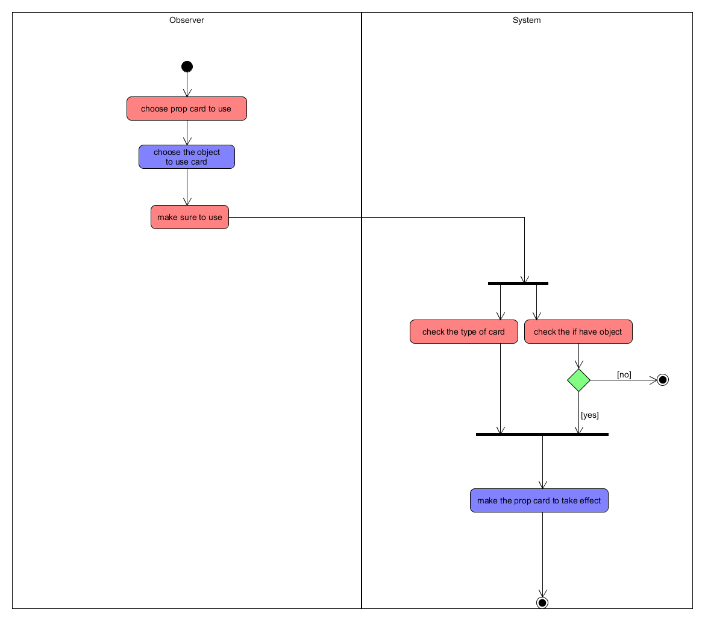

1. State transition diagram of key objects:

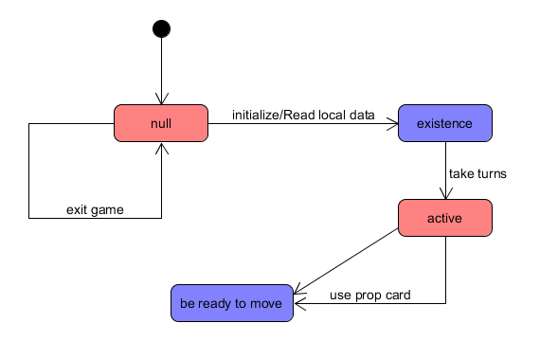

## Use case three：Move

1. Design of input interface, output and database design:

* input interface：

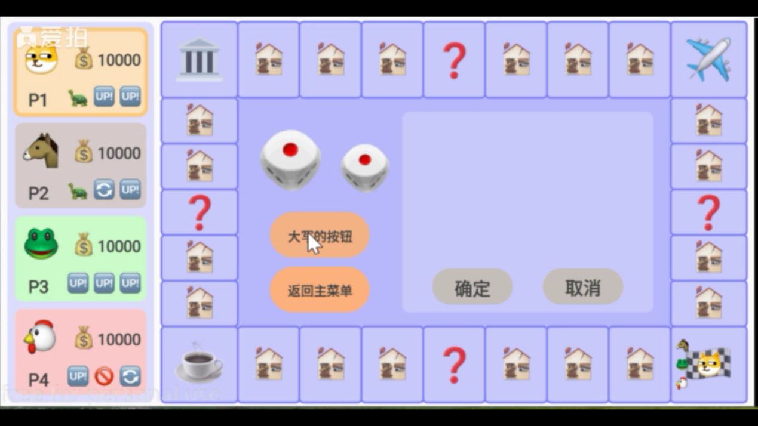

Entry: the state of big button

* output interface：

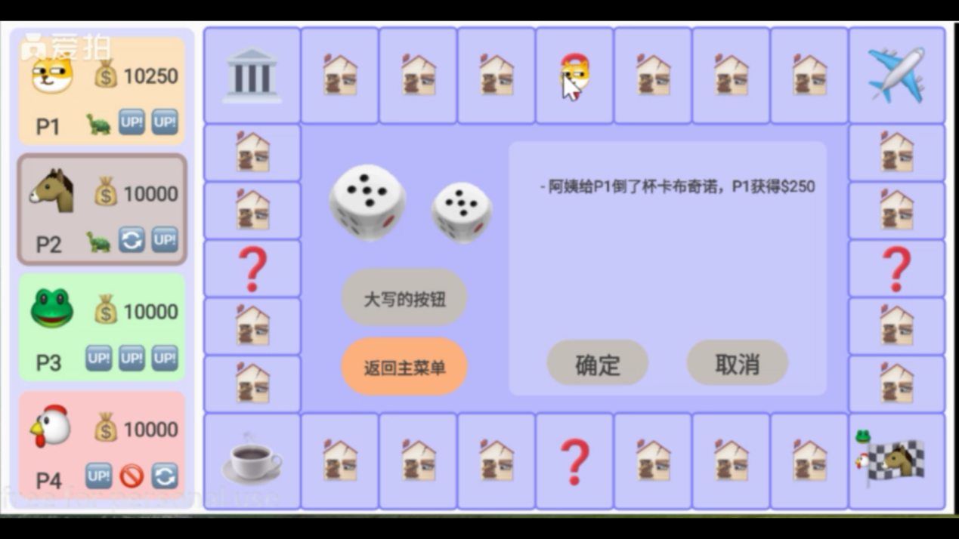

* database design:

no

1. Participation class:

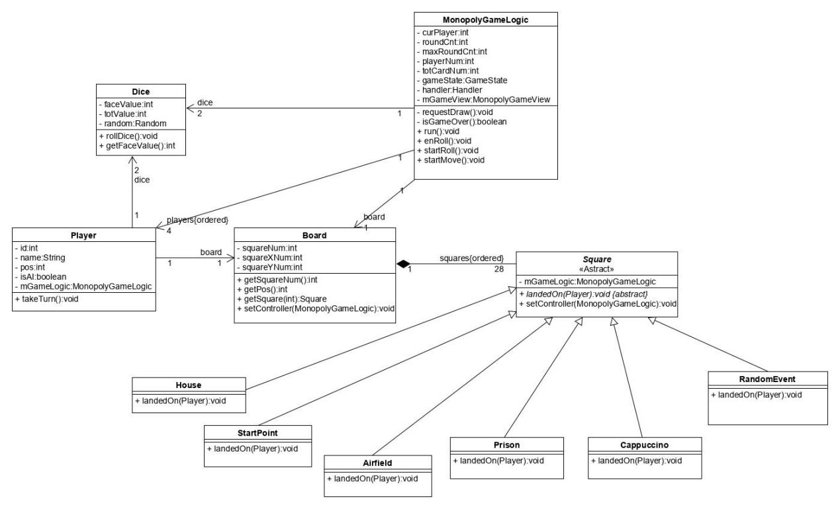

Square: An abstract class, used to derive all kinds of building classes, which have different trigger event.

1. Activity diagram:

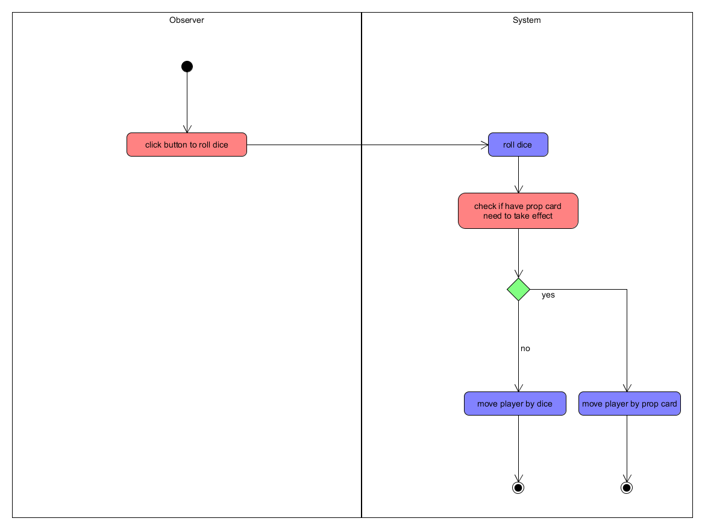

1. State transition diagram of key objects:

Player[i]:

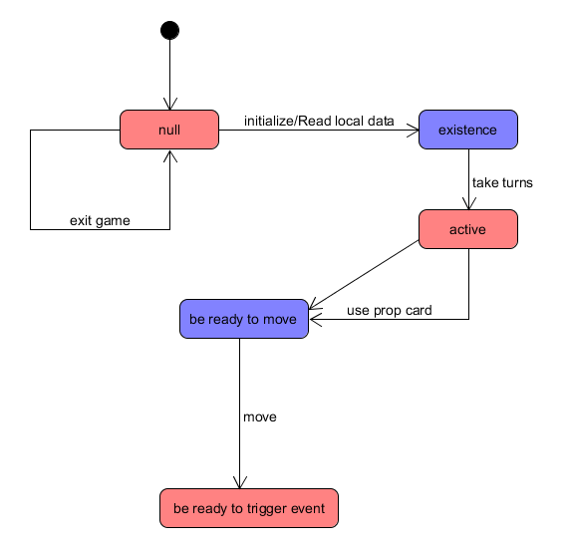

## Use case four：Trigger events in a square

1. Design of input interface, output and database design:

* input interface：

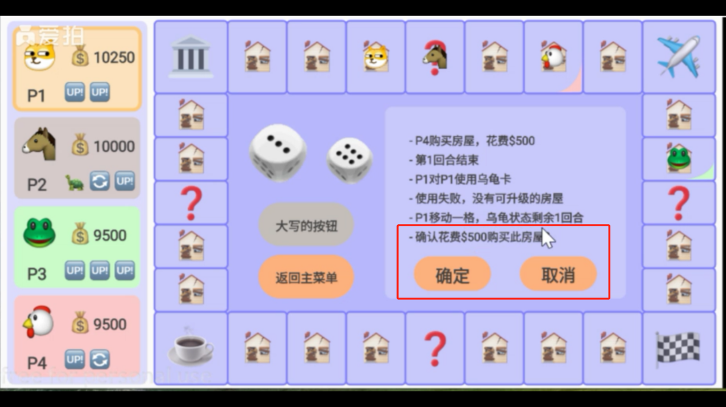

* output interface：

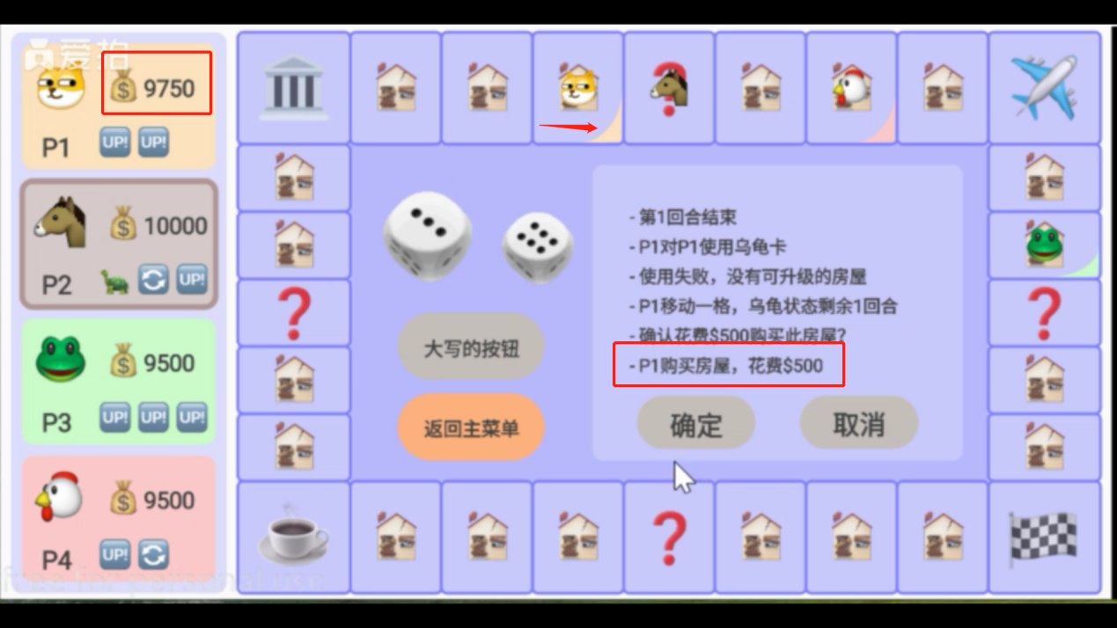

* database design:

no

1. Participation class:

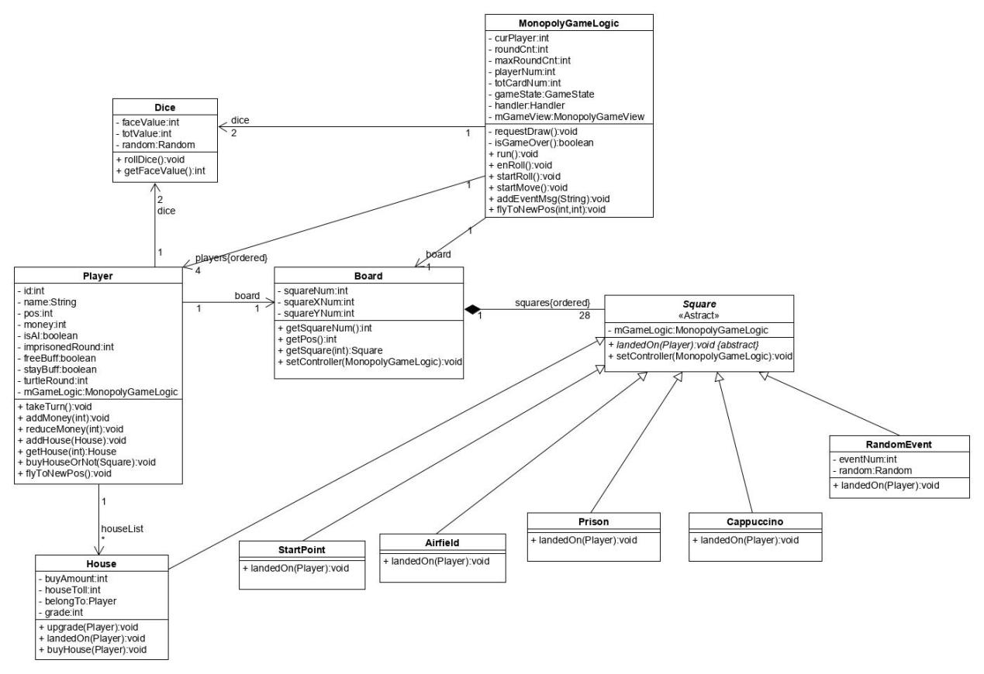

Square: An abstract class, used to derive all kinds of building classes, which have different trigger event.

1. Activity diagram:

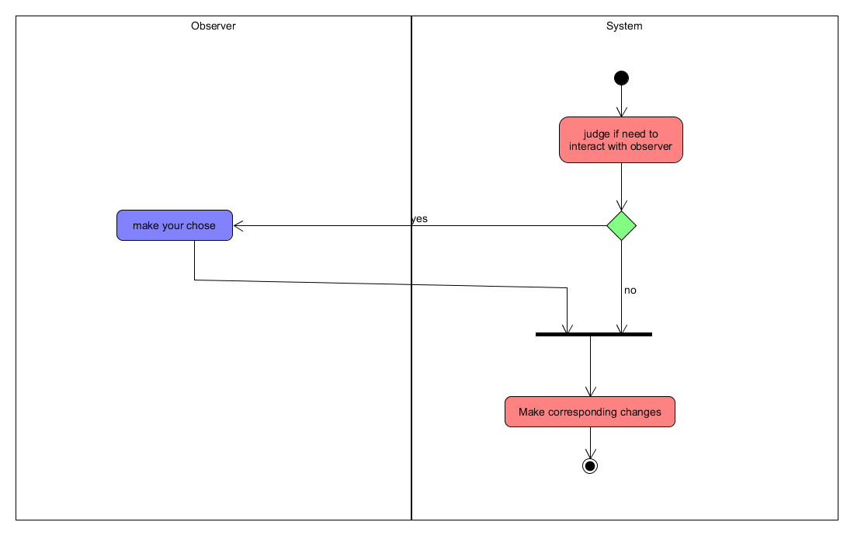

1. State transition diagram of key objects:

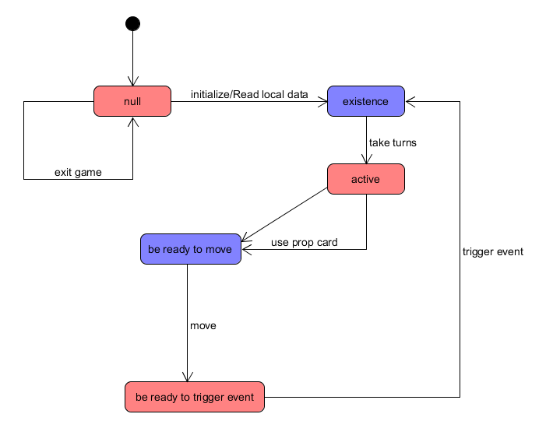

## Use case three：Save Game

1. Design of input interface, output and database design:

* input interface：

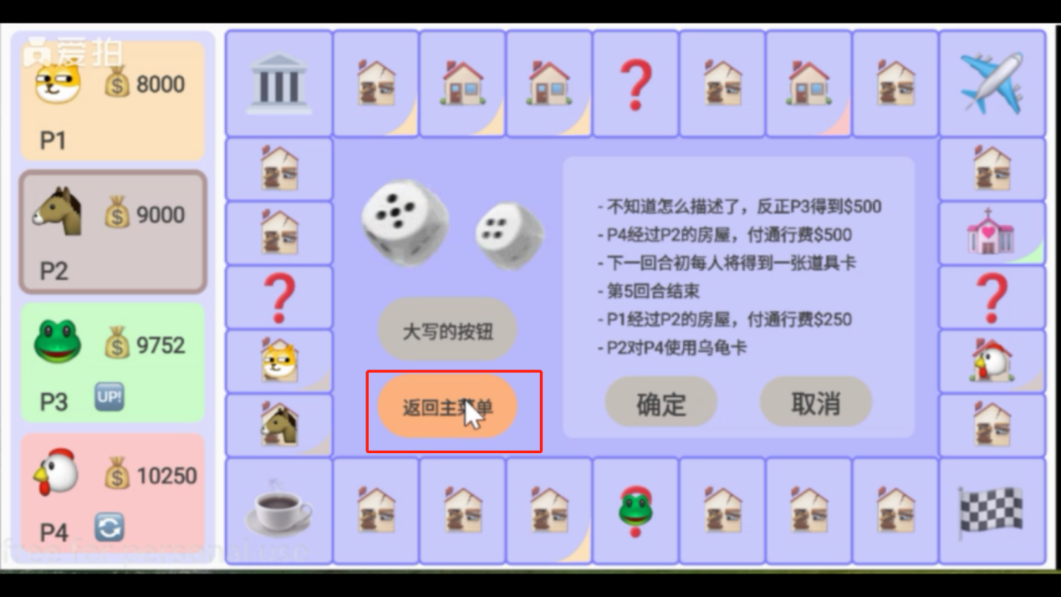

Entry: return menu button coordinates

* output interface：

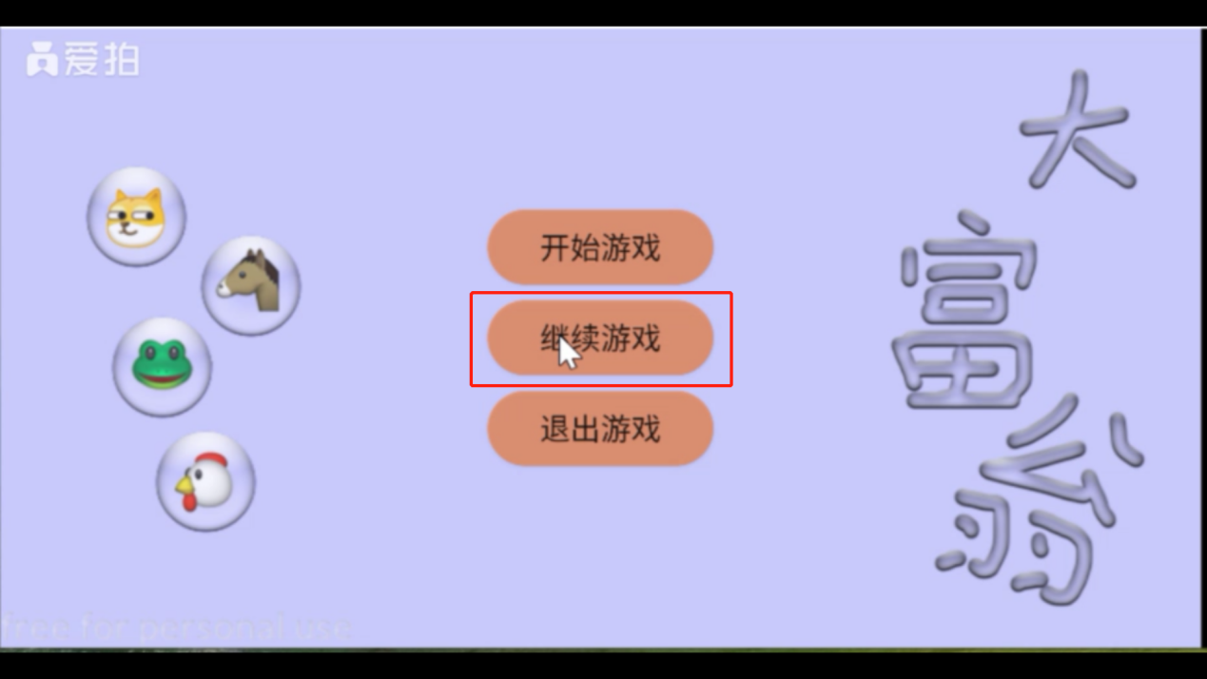

* database design:

no

1. Participation class:

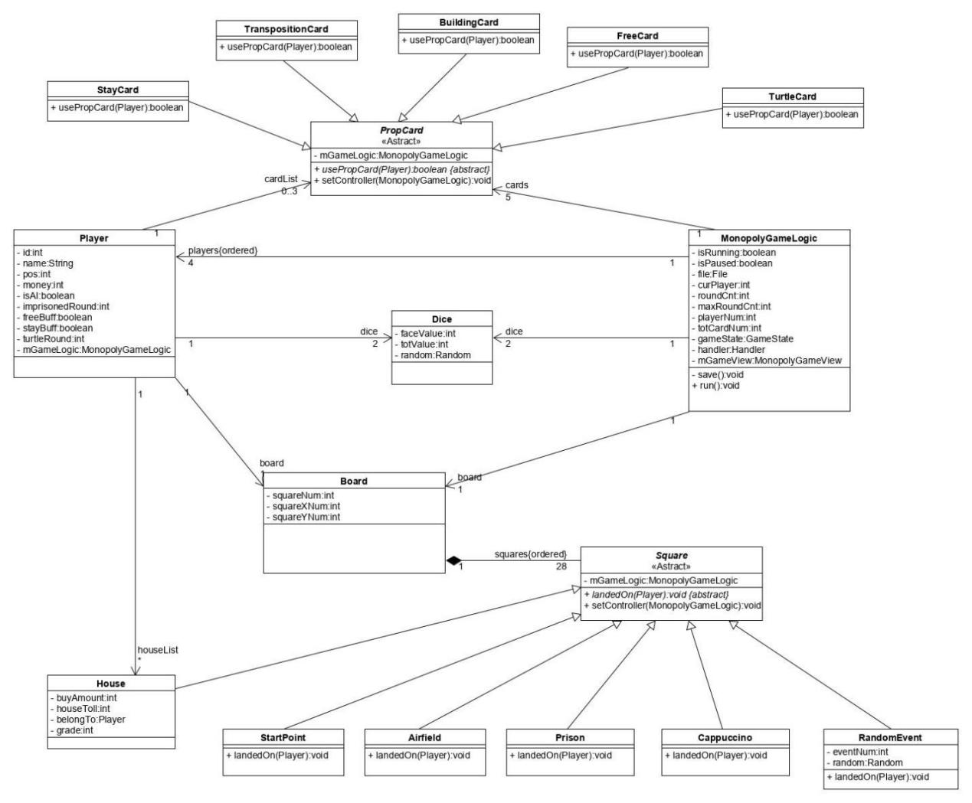

1. Activity diagram:

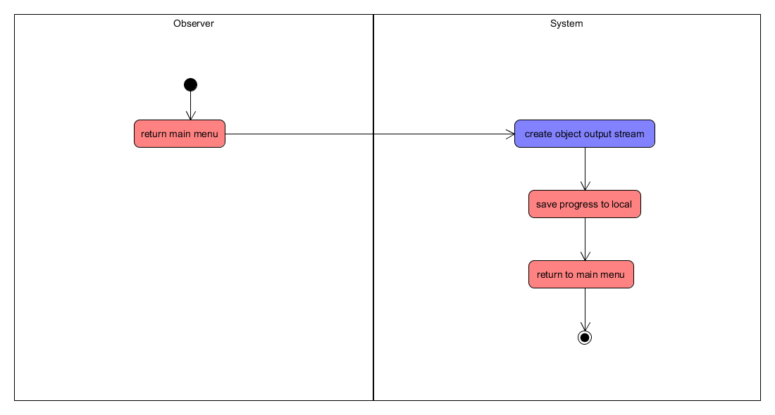

1. State transition diagram of key objects:

